Twilight of the Cod

By Robert Kunzig|Saturday, April 01, 1995
-------------------------------------------------------------------------------------------------------------------------------------------------------------------------------------------
In the Massachusetts statehouse, high above the gallery in the House of Representatives, directly opposite the painting of John Hancock proposing the Bill of Rights, there hangs a five-foot-long wooden codfish. It is painted gold with scarlet gills, and it has been there for exactly a century--ever since it was moved from the old House chamber, where it had hung for a century before that. The transfer of the Sacred Cod on March 7, 1895, was an occasion for pomp and soaring oratory. A committee of 15 legislators was appointed to fetch the fish.
Two by two, they followed the sergeant at arms into the old chamber, watched as the cod was lowered onto a bier draped with the American flag, and then marched behind the four pages who carried it into the new hall. There the cod and its entourage were greeted with a deep bow by the senator from Gloucester, the state’s preeminent fishing port. The rest of the assembly rose to their feet and applauded the fish vigorously. Everybody who could make a pretext for touching its fins or for holding it straight on the stretcher did so, the Boston Daily Globe reported the next day. The triumph of the codfish was front-page news in both the Globe and the Boston Herald; each devoted nearly half a broadsheet to the event.
------------------------------------------------------------------------------------------------------------
The early 1890s were good years for cod fishing in Massachusetts, and in particular for Gloucester. At the 1893 World Columbian Exposition in Chicago, Gloucester mounted an elaborate exhibit, featuring a scale model of its thriving waterfront. That same year the Portuguese immigrants to that waterfront finished building themselves a church, Our Lady of Good Voyage, and topped it with a gaily painted statue: Madonna with Schooner. Rudyard Kipling was holed up in Brattleboro, Vermont, in the 1890s, writing Captains Courageous, his paean to the Gloucestermen who went down to the sea in schooners and dories. Sailing on the rich offshore banks, from Georges Bank off Cape Cod to the Grand Banks of Newfoundland; staying at sea for months; fishing with hook and line from small boats tossed on large waves, those men sustained an industry whose reach was global. In 1895, fishermen caught 60,000 tons of cod in the waters off New England. In May of that year, two months after the shifting of the Sacred Cod, one man landed the Patriarch Cod--a six-foot-long, 2111Ž2-pound fish. Its likes have never been seen again. Cod do not live that long these days.
------------------------------------------------------------------------------------------------------------
Fishing has changed a lot in the last century. On a bleak, sleety morning last November, a few dozen descendants of the captains courageous gathered 15 miles inland from Gloucester, and about as far from Kipling’s Gloucester as it is possible to get. They came, in their flannel shirts and jeans and baseball caps, to a Holiday Inn set in the strip-mall ugliness of Route 1 in Peabody. They sat, in a pink, drop-ceilinged ballroom, under a reflecting disco ball, and listened to their fate being discussed by men in suits--the Groundfish Committee of the New England Fishery Management Council. They watched, more or less mutely, a computer-model presentation of the options open to this committee. The presentation was opaque even to scientists in the audience, and the committee’s discussion was lackluster and at times nonexistent. But it mattered little: everyone knew that the options were all but nonexistent, too. A month earlier the council had decided that fishing for cod on Georges Bank--as well as for haddock and yellowtail flounder, the two other important bottom-dwelling fish--must essentially be stopped. The committee’s task was to work out the details.
That such a long and fruitful history should meet so wretched an end: on that happy afternoon a century ago in the statehouse it could not have seemed possible. This sedate and solitary fish, Congressman James Gallivan of Boston had told the assembly, commemorates democracy. It celebrates the rise of free institutions. It emphasizes progress. It epitomizes Massachusetts. This was not just posturing. Endless resources, free for the taking, are what made America possible, and it started with cod. Cod spurred the settlement of the New World. They were its first industry and export. They fed the Pilgrims. And now, after 500 years, from Georges Bank right up to the Grand, they are all but gone.
------------------------------------------------------------------------------------------------------------
Atlantic cod, Gadus morhua, have been around a lot longer than we have, probably more than 10 million years. Cod survived even the ice ages, presumably by moving south. Today they live from the Barents Sea north of Norway down the European coast as far south as the Bay of Biscay, and from northern Labrador and Greenland down the American coast as far as Cape Hatteras. As far as biologists can tell, the cod that live today on opposite sides of the Atlantic and even at different points along the North American coast form distinct stocks, or populations. But they are still in occasional touch with one another and still belong to the same species. In 1961, for instance, a fish that had been tagged by British researchers in the North Sea four years earlier was caught off Newfoundland, after a journey of more than 2,000 miles.
------------------------------------------------------------------------------------------------------------
Cod live in coastal waters, a thousand feet deep or less, because that is where they find food: small animals that feed on the single-celled plants called phytoplankton. Phytoplankton have to float near the surface to capture sunlight, but their nutrients come mostly from seafloor sediments. In shallow water, tides and currents can readily stir nutrients up to the surface. This is especially true of the shallow offshore banks that run along the Atlantic coast from New England to Newfoundland. Since the last ice age, they have been an archipelago of productivity, in particular of cod.
The banks themselves were created during some earlier glaciation, when is not clear. At that distant sometime, between 5 million and a hundred thousand years ago, sea level was much lower than it is today--the water was stacked up in continental ice sheets. The continental shelf that is now submerged was then a flat coastal plain dipping gently toward the sea. Many rivers meandered over this plain, and over the millennia their wandering channels dug a series of basins into it. Along the ancient coast, the rivers left a chain of low hills, steep on the inland side and gently dipping toward the sea, and punctured by just a few large estuaries. In the last ice age, glaciers surged right up to the edge of the hills and dug the basins even deeper. When the ice sheets finally melted and the sea level rose, the basins were flooded and the hills became submerged offshore banks. The Gulf of Maine is one such basin; Georges Bank, at the mouth of the Gulf of Maine, is one such bank. The banks are often only a few tens of feet deep at their crests and never more than a few hundred. They are covered with sand and gravel dumped by the glaciers.
------------------------------------------------------------------------------------------------------------
Cod are groundfish--bottom dwellers--and have the mottled coloring of sand or gravel. In other ways too they are not the stuff of poetry. They are large, typically two to three feet long and eight pounds or so at maturity, but not exceptionally large; strong swimmers, with their powerful tail fin, but not exceptional ones; agile swimmers, thanks to fins on the back and belly that act like rudders, and ones on the sides that act like horizontal thrusters--but again, not exceptional. When you look at a cod in a tank, and it looks back with its big round eyes, you think: fish. Cod are a kind of essence of fish, a default setting from which other fish are extravagant variations. Cod are generalists. And they are omnivorous survival machines.
------------------------------------------------------------------------------------------------------------

Fisheries biologists do not really know what happens to the cod larvae that do not make it on Georges Bank--and still less off Newfoundland. Nor do they know why in some years many more larvae survive than in others. What they do know is that the difference between a good year and a bad year did not used to matter as much as it does now. A population of fish that live 25 years and lay several million eggs a year each is in no danger from the occasional environmental insult. If one year’s larvae prove a flop, there are 24 other year classes in the water to pick up the slack. Nor is it only chance environmental fluctuations that cod have adapted to. Over millions of years, they have repeatedly endured the slow obliteration of their habitat by advancing or retreating glaciers and have still thrived.
And yet in one way cod are not perfectly adapted to their present environment. They have a fatal flaw: firm white flesh, free of oil and bones, which is easily preserved by salting or freezing, and which does well in all sorts of recipes. For helping to feed the expansion of European civilization, Gadus morhua is now paying a heavy price.
------------------------------------------------------------------------------------------------------------
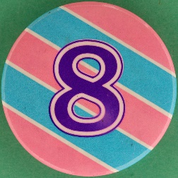
The technology of New World cod fishing changed not at all during the first three centuries after John Cabot’s voyage of 1497, and little during the next. It was more or less like sport fishing today, but without the rods and in worse weather. Men stood or sat in a boat and dropped hooked lines over the side.
During the haddock heyday, cod enjoyed a period of obscurity; in 1953 only 8,100 tons were taken off Georges, a record low. In the Newfoundland cod fishery, too, the first half of the twentieth century was relatively quiet. French and Portuguese otter trawlers began to work the Grand Banks, while Newfoundlanders continued to fish inshore in traditional ways (although many now had motors on their dories). The catch slowly increased, but it did not skyrocket--until after 1954. That is when the British ship Fairtry appeared on the horizon.
The Fairtry was a new kind of fishing boat: a factory trawler. It was 280 feet long and displaced 2,600 tons, which made it several times larger than the largest trawler of the day--but much smaller than some of the ships that were soon to follow it. The Fairtry had been commissioned by a Scottish whaling firm that was keen to expand out of factory whaling now that whale stocks were in decline. Its maiden voyage to the Grand Banks was a success; the biggest problem was that the huge net was sometimes filled with so many tons of fish that the gear gave way under the strain. Nothing is more provoking, the captain of the Fairtry wrote in one of his reports, than to see this happen or the cod end burst and the sea covered with dying fish.
By the 1960s the Fairtry fishing ship had been joined on the North American banks by many more factory ships, not from North America but from the Soviet Union, Germany, and other nations. The largest displaced some 8,000 tons. All were designed to fillet and freeze the fish immediately; and all were designed to catch huge amounts of fish. In an hour, one factory ship could haul in as much cod, around a hundred tons, as a typical boat of the sixteenth century could land in a season. In 1968, 810,000 tons of cod were caught off Labrador and on the northern Grand Banks--nearly three times more than had ever been caught in a single year before 1954.
The result, in retrospect, seems entirely predictable. It may even seem astonishing that we let it happen: that in the space of two decades we let foreign ships all but wipe out one of our great natural resources. But the freedom of the high seas was a tradition that was not easily jettisoned. Moreover, except among fisheries scientists, and even among some of them, the old prejudice of an inexhaustible sea still held sway. No one thought you could overfish cod on the banks. By the mid-1970s, though, it was clear something had happened. The cod catch had plummeted to less than 200,000 tons off Newfoundland, and on Georges Bank to less than 30,000 tons. The haddock on Georges were practically gone. In 1977, with their fishermen screaming for help, both Canada and the United States extended their territorial waters out to the present limit, 200 miles offshore. That excluded foreign vessels from most of the fishing.
------------------------------------------------------------------------------------------------------------
What is truly astonishing is what happened next. With the factory ships gone, both Canada and the United States had a chance to re-create a sustainable cod fishery. Neither country did. And the fact that biologists were still just getting to know cod--and still learning how to count their far from inexhaustible numbers--was to contribute to that failure, particularly in Newfoundland.
Jeffrey Hutchings, a Newfoundland native, has devoted the past couple of years of his life to deconstructing the disaster. “You can’t live here and not be touched by what’s been happening,” says Hutchings. “My family is here seven generations. The fishery is everything. That’s it. There’s almost no industry; there’s no other natural resources except for some pulp and paper, a little bit of mining. It’s always been the fishery, and everything is linked to the fishery. So this kind of work is very different from other scientific work--if we get it wrong, this is going to affect a lot of people.”
------------------------------------------------------------------------------------------------------------
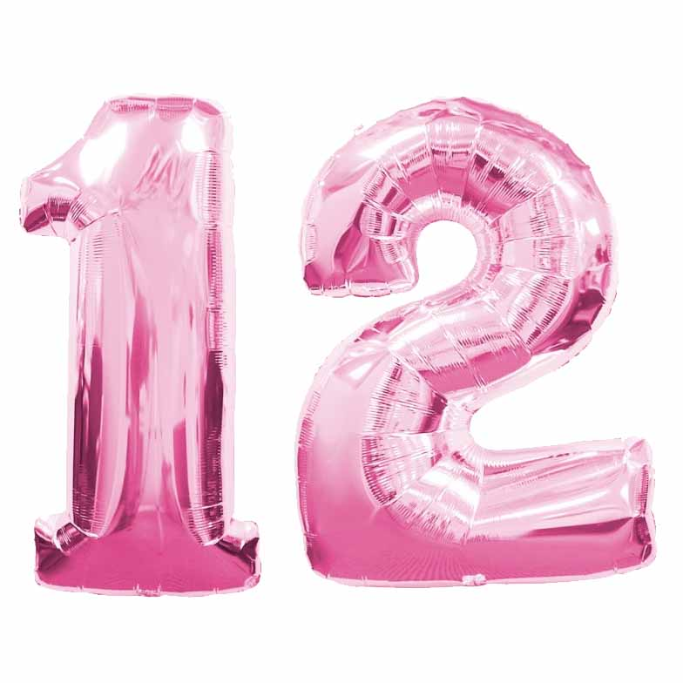
After foreigners were kicked off the Newfoundland banks, a brief period of euphoria descended on the province. This was to be Newfoundland’s chance at last. Its inhabitants were poor, unemployed, and still living, some of them, in outports that could not be reached by road. Past efforts to diversify the economy had more or less failed. Maybe the path to the twentieth century lay with cod after all. The foreigners had shown just how many fish could be caught; now those fish would belong to Newfoundland. The government deliberately encouraged the expansion of the offshore fishery, even buying a major trawling company itself. They predicted the diminished stock would rebound rapidly. They said the cod catch, which had fallen to 139,000 tons by 1978, could safely be increased to 350,000 tons by 1985--and all of that for Newfoundland.
But the cod were simply not there in the numbers DFO was claiming. The agency was cheerleading rather than regulating. Although fishermen were not catching as many cod as DFO was allowing them to, they were catching more than the cod population could sustain. By the mid-1980s the problem was apparent, to outside critics anyway, in the DFO’s own data. Once most of the fish from the late 1970s and early 1980s were dead, the VPA revealed that there had been many fewer of them than DFO had claimed at the time. That meant fishermen had been harvesting a much higher percentage of the cod stock than DFO had thought-- so high that the stock could not be growing at the rate DFO had projected.
------------------------------------------------------------------------------------------------------------
By then it was too late. Nowhere in the world do scientists dictate how many fish are to be caught; that decision is ultimately a political one. By 1989 the political and economic momentum behind an expanded Newfoundland fishery was too great. Not wanting to throw thousands of people out of work, the Minister of Fisheries and Oceans rejected his stock assessors’ advice to cut the 1989 cod quota all at once by more than half, to 125,000 tons. Instead he cut it by a tenth. Politically it’s very difficult to reduce fishing, says Myers. Particularly because there’s uncertainty--you’re causing great hardship, and you’re not certain. There are a lot of possible errors. But in fact the error was in the other direction--there were even fewer fish and higher mortality than what DFO thought. And toward the end, as the cod population declined, people tried to maintain their catch rates to maintain their income. So they fished harder. Inshore fishermen were going in small boats 100 miles offshore and setting bottom gill nets--they were going way the hell out under incredibly dangerous conditions. That caused the fish population to go down more quickly, which caused the fishermen to fish harder.
------------------------------------------------------------------------------------------------------------
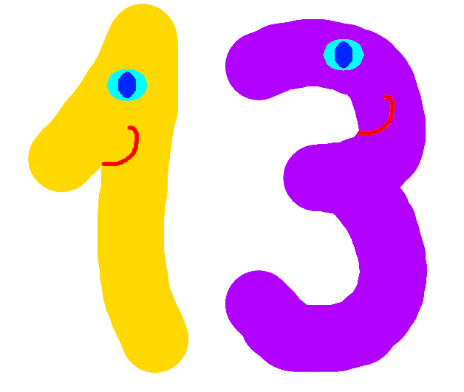
In July 1992 the minister was forced to close the cod fishery entirely. By then there were next to no cod of spawning age, seven or older, left. There were just 22,000 tons’ worth, less than a quarter of what there had been in 1977, after the factory trawlers had done their worst, and around an eightieth of the spawner biomass in 1962. Recent history seems to confirm that the DFO’s initial assumption--that there can be plenty of cod babies even when there are few cod mothers--was wishful thinking. After two and a half years, there has been little recovery, and no one knows when the moratorium will be lifted. It has thrown 30,000 people out of work in Newfoundland, out of a population of 570,000.
------------------------------------------------------------------------------------------------------------
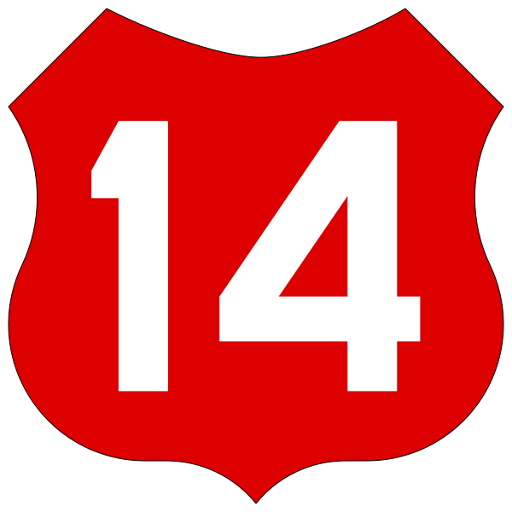
What is to be done? The few cod that are left are doing their best already--still chasing capelin and herring, still stemming the currents on the banks, still ascending by twos from their diminished schools to couple gently in the gray unquiet Atlantic. On Georges Bank, at least, they are responding just as biologists would expect to a predator that is slaughtering them: they are spawning sooner--at age two now instead of three. They are living faster because they are dying younger.
Meanwhile, as their numbers have declined, they have surrendered their dominance on the bank to other species, such as skates and spiny dogfish. These fish are less attractive to consumers (although fishermen are going after them nonetheless), and they prey on young cod. How this will affect the recovery of cod, no one knows. At Memorial University in Newfoundland, biologists are trying to perfect a system for hatching cod, in hopes of boosting the wild stocks. Maybe this will work--but it has been tried repeatedly without success.
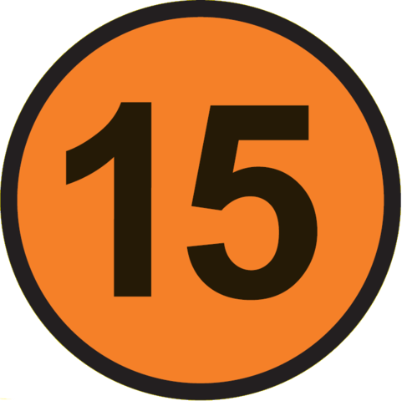
------------------------------------------------------------------------------------------------------------
American consumers have not suffered much yet from the Atlantic cod crisis; for the moment, the slack is being taken up by Pacific cod, by Norwegian and Russian cod from the Barents Sea, and by similar fish such as pollack, which are now being swept up by factory ships off Alaska. But the U.S. and Canadian governments are having to pay dearly for the irrationality they permitted in their fisheries. The U.S. government has already allocated $60 million to easing the pain of Atlantic fishermen, Canada more than $600 million. If these programs keep too many boats chasing too few fish, they will be counterproductive in the end. In New England there is much talk of paying fishermen not to fish, as some farmers are paid not to farm. The idea is for the government to buy boats and get rid of them. Fishermen tend to feel this is no more than their due.
Most fishermen recognize that the fishery is in trouble. But most are anything but rich, and many chafe at restraints. Freedom to work when and how they want is one of the things that draw people to fishing; many believe they have a right to fish. What the cod crisis demonstrates is that the world has become too small, and our own numbers too large, for such a right to be acknowledged anymore. It is a privilege that has been abused. That is hard to accept.
You’re talking about people’s livelihoods, says Rosenberg. A scientist looks at it simplistically: ‘The harvest rate should be this, and it’s not, so you should reduce it.’ But when you reduce it, who goes out of business, who has to move away, and who is unemployed? The difficulty, though, is that at some point there is a biological bottom line.
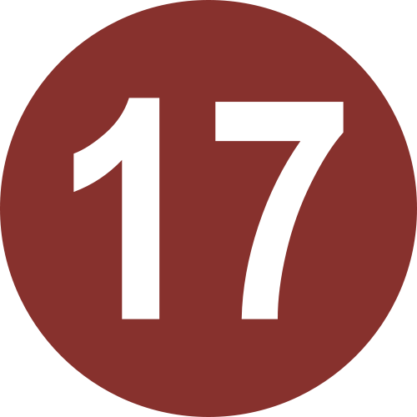
------------------------------------------------------------------------------------------------------------
All over the world people are failing to hear that message; all over the world, out of desperation and greed, ignorance and mismanagement, people are finding the bottom of fish stocks that once seemed bottomless. Yet it is still shocking that it should happen to cod--stolid, prolific, resilient cod, numberless cod, beef of the sea. It is shocking precisely because we never really did hold cod sacred, not the real flesh-and-blood animals anyway. Though we hardly knew them, we took them for granted--much as hunters once took the buffalo for granted when the prairie was black with them. There is no great mystery about what happened to the buffalo, and none either about what happened to the cod off northeastern America. Men like the ones in that Holiday Inn ballroom--the last of the buffalo hunters--caught them. And the rest of us ate them.
------------------------------------------------------------------------------------------------------------------------------------------

