Data for Biology Test 2-567 (Retake) Std 2/Obj’s 5, 6 & 7 – Mitosis, Organ Systems & Homeostasis
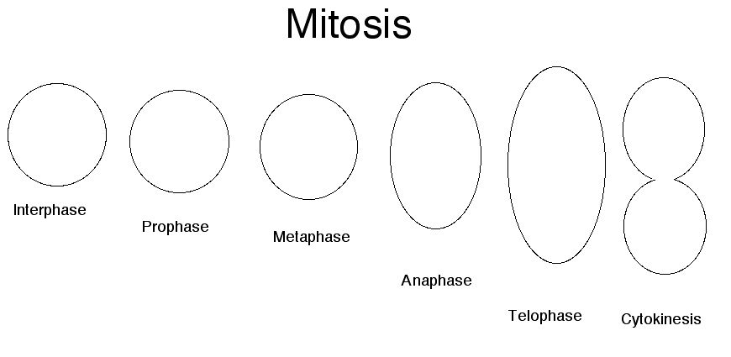

A
B
C
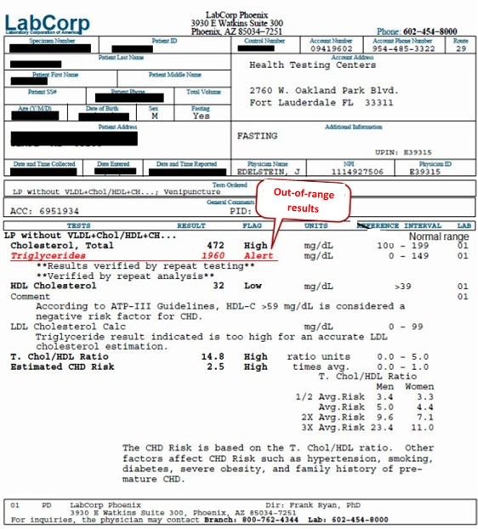
A
B
D
E
C

