Study Guide Standard 5, Objective 3 Evolution and Classification

Binomial Nomenclature:

Carl Linneaus:

K P C O F G S

Dichotomous: _____________________________________________________________________

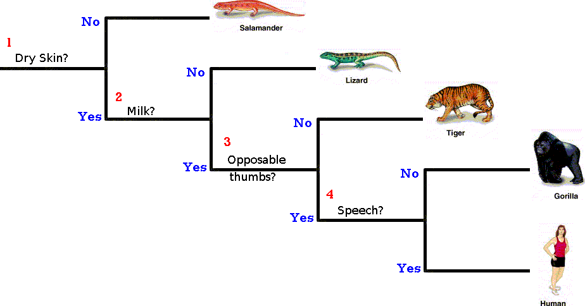
Dichotomous Key

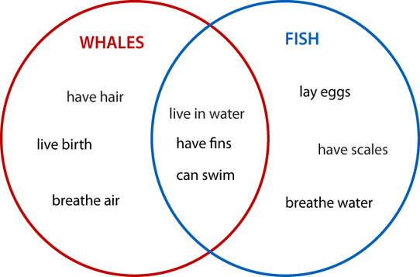

Venn Diagram: __________________________

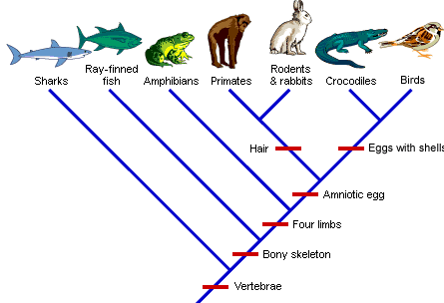

Cladogram:

Jelly Bellies Classification

Classifying Life – Computer Lab pbs.org/wgbh/nova/nature/classifying-life.html

Classifying Trees at SRMS – Activity/Computer Lab oregonstate.edu/trees/dichotomous_key.html

Cladogram Worksheet

Tree of Life Puzzle

Current Science Event – New Evolution Theories

