Study Guide Standard 5, Objective 3 Evolution and Classification

Binomial Nomenclature:

Carl Linneaus:

K P C O F G S

Dichotomous: _____________________________________________________________________

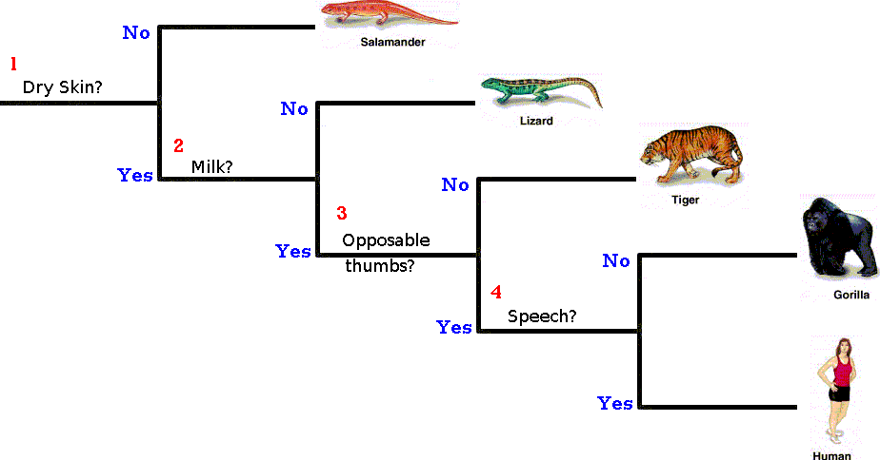
Dichotomous Key

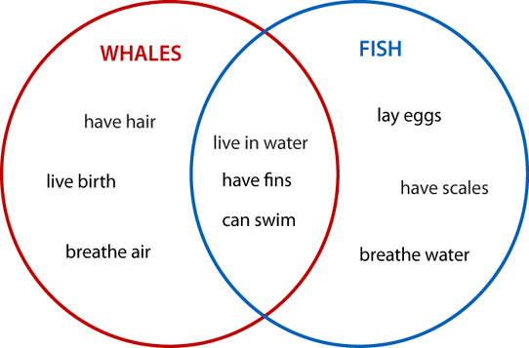

Venn Diagram: __________________________

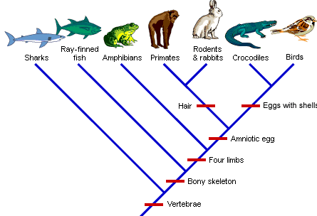

Cladogram:

Classifying Life – Computer Lab (pbs.org/wgbh/nova/nature/classifying-life.html)

Animal Classification – Computer Lab (animaldiversity.ummz.umich.edu/site/accounts/information/Animalia.html)

