Freshman Biology Standard 5/Objective 2 – Study Guide

Evolution is a __________________!

Evolution: ________________________________________________________________________.

It is rational to believe

that mountains evolve.

Why?

What type of evolution is the evolution of mountains?

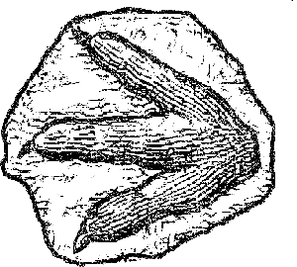
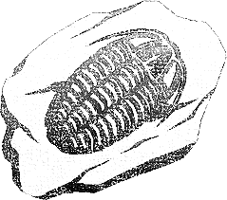
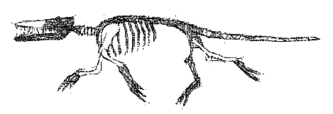

How are fossils evidence of evolution?

Observation:

Inference:

Chemical Dating:
Half-Life:

Embryology:

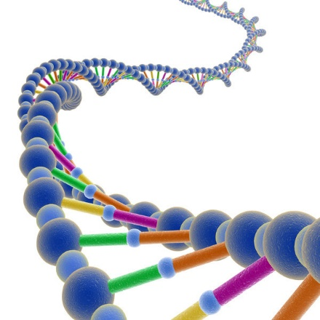
DNA Structure Similarities

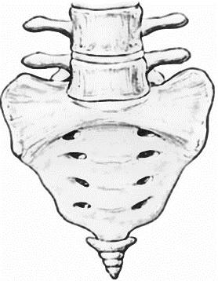
Vestigial Structures (Vestiges):
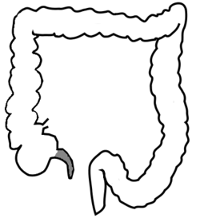
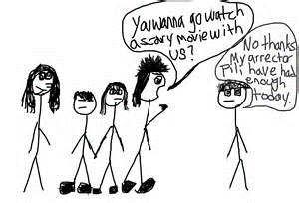

Examples:

Homologous Structures:
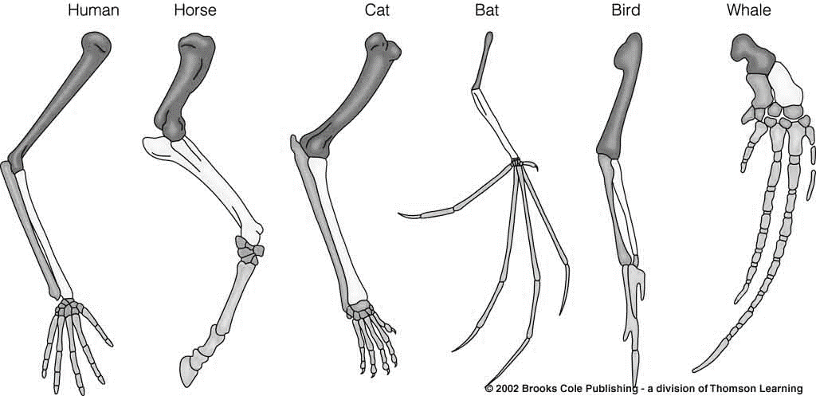
_____________ ______________ _____________ ____________ _______________ ____________

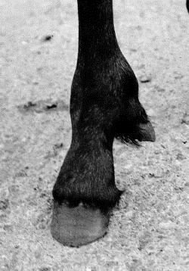
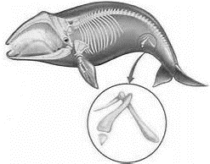
Atavistic Structures (Atavism):

Similar DNA:
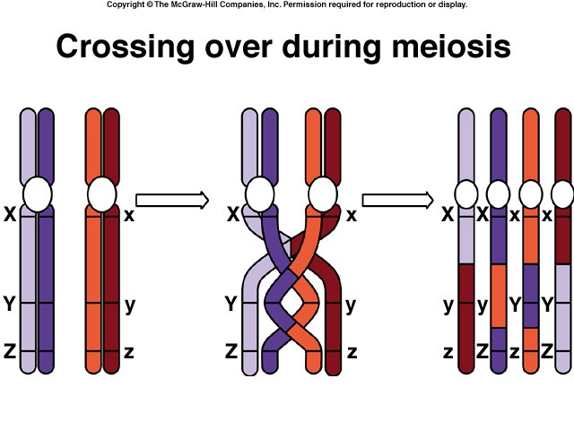

____________________ may happen during _______________________ or during

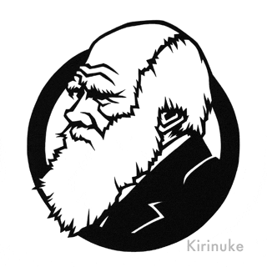
___________________________. It is a _______________________________ change in the DNA sequence.

Charles Darwin wrote:

Darwin’s Big Ideas: 1.

2.

What is “Tree Thinking”?

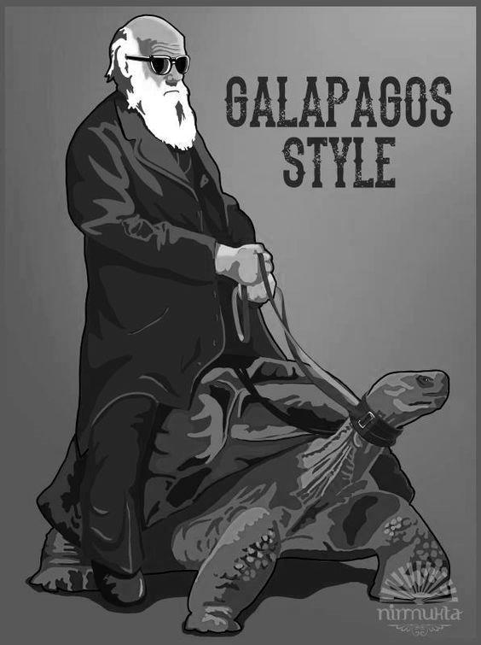

What Darwin Never Knew: Video and Worksheet
http://www.bing.com/videos/search?q=what+darwin+never+knew+pbs&view=detail&mid=FC09AEE1C4F111951454FC09AEE1C4F111951454&FORM=VIRE

Building a History from Artifacts: Observation and Inference Activity

