Mrs. Clelland – 9th Grade Biology

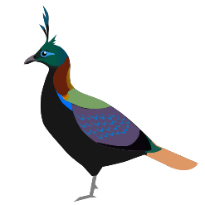
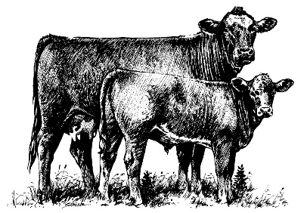
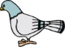
Study Guide Notes Standard 5, Objective 1 Evolution and Classification

Environmental Factors
- Examples – Predation, Catastrophe, Climate Change, Competition, Disease, Separation, Geographic Isolation
- Environment does not cause mutations or genetic variability to happen.
- Environment takes advantage of mutations or genetic variability already there.
- Video Clip – Selection for Tuskless Elephants

Selective Breeding
- Examples – livestock, pigeons, dogs, cats, pets, zoos
- Artificial selection
- Humans use animal breeding and plant breeding to selectively develop particular phenotypic traits (characteristics).
- Humans choose which males and females will sexually reproduce and have offspring together.
- FFA Projects – sheep
- Current Science Event – Selective Breeding

Natural Selection
- Process where organisms better adapted to their environment tend to survive and produce more offspring.
- First expounded by Charles Darwin.
- Main process that brings about evolution.
- Examples – Darwin’s finches (beaks), peppered moths (black/white), Birds of Paradise (songs, mating rituals, bright colors)
- Teddy Grahams Activity
- Survival of the Flattest Activity
- Evolution of Canis pedatus Worksheet
- Birds of Paradise Project (Cornell Ornithology Lab) – Computer Lab Interactives http://www.birdsofparadiseproject.org/
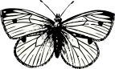
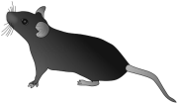
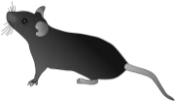
- Natural Selection Worksheet – Evolution by Natural Selection (Peppered Moth)

