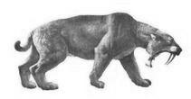
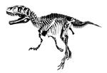
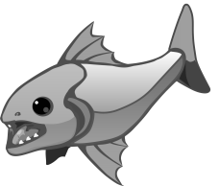
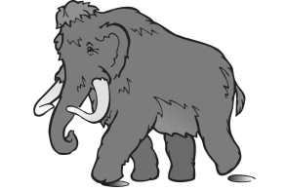
Freshman Biology Standard 5/Objective 1 – Study Guide

Natural Selection

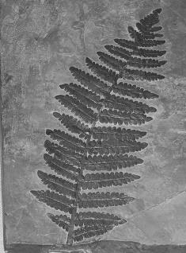
Environmental Factors:

Environment _____________________________ mutations or genetic variation to happen.

Environment ____________________________ mutations or genetic variability _______________.

How are Tuskless Elephants an example of Natural Selection?

Tuskless

Elephants
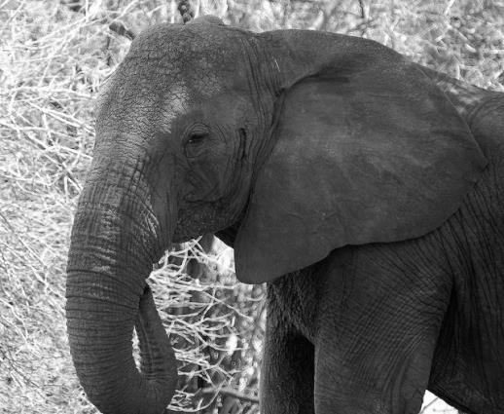

Selective Breeding

What are some examples of Selective Breeding?

Natural Selection

What are some examples of Natural Selection?

