Freshman Biology Standard 3/Objective 1 – Study Guide

How are organisms ordered? __________________________________________________________________________________________________________________________________________________________________________________________________________________

______________ relates to ______________. They go hand-in-hand.
_____________ and ____________________ function together to provide __________________ in organisms.

Homeostasis

The functioning of organs depends upon ____________ organ systems.

Structure: ______________ is the study of . Structure is .

Function: ______________ is the study of . Function is .
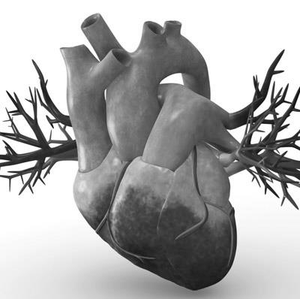

Heart

Structure:

Function:

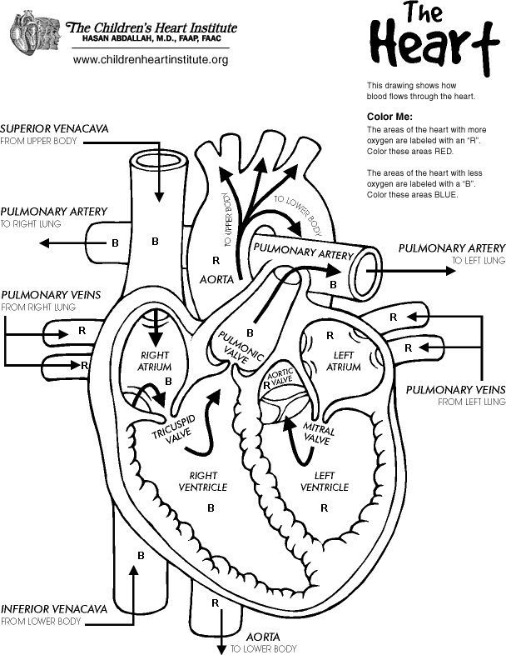

Heart/Blood Pathway:

Vena Cava

How does the structure of the heart allow it to perform its function?
______________________________________________________________________
__________________________________________________________________________________________________________________________________________________________________________________________________________________

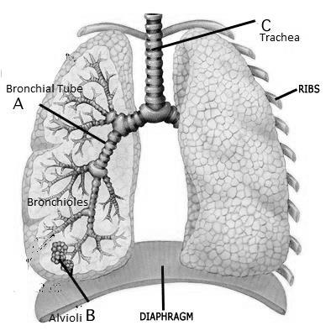

Lungs

Structure

Function

How does the structure of the lungs allow them to perform their function?
__________________________________________________________________________________________________________________________________________________________________________________________________________________
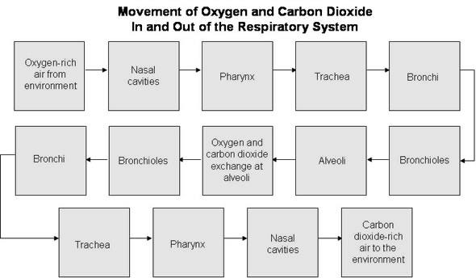
______________________________________________________________________

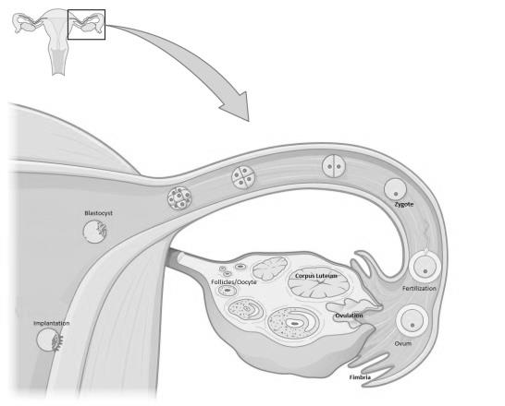

Ovaries

Structure

Function

How does the structure of the ovary allow it to perform its function?
__________________________________________________________________________________________________________________________________________________________________________________________________________________

Leaf

Structure: ___________________________________________________________
___________________________________________________________
Function: ___________________________________________________________
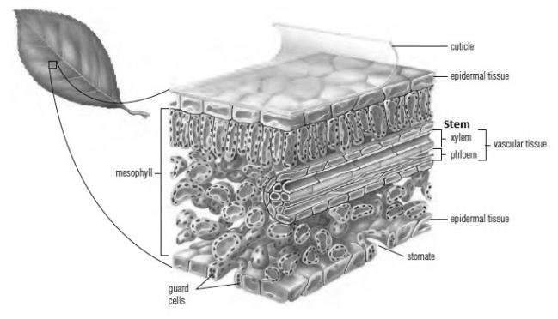
___________________________________________________________

How does the structure of a leaf allow it to perform its function?
__________________________________________________________________________________________________________________________________________________________________________________________________________________
______________________________________________________________________
______________________________________________________________________

Stem

Structure: ___________________________________________________________
___________________________________________________________
___________________________________________________________
Function: ___________________________________________________________
___________________________________________________________
___________________________________________________________
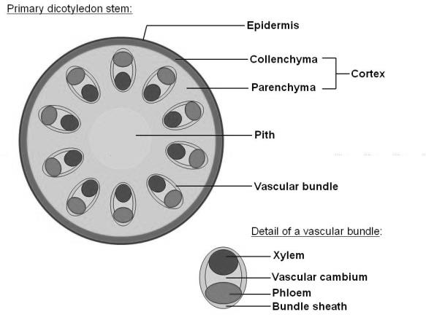
How does the structure of a plant stem allow it to perform its function?
__________________________________________________________________________________________________________________________________________________________________________________________________________________
______________________________________________________________________
______________________________________________________________________

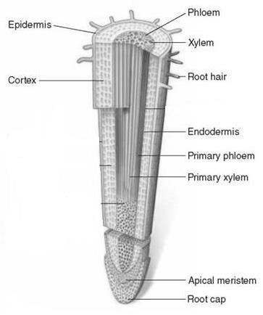
Root

Structure:

Function:

How does the structure of a plant stem allow it to perform its
function?

Integumentary System

Structure:

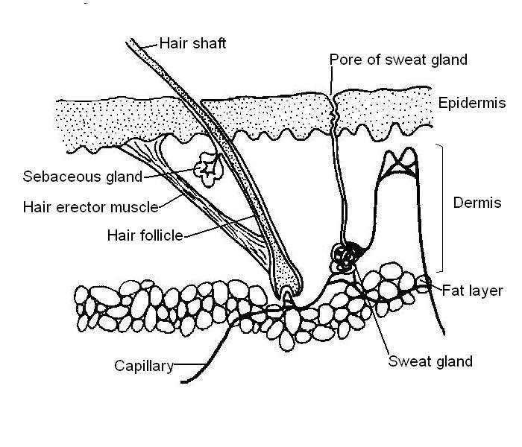
Function:
How does the structure of the skin allow it to perform its function?
__________________________________________________________________________________________________________________________________________________________________________________________________________________
______________________________________________________________________
______________________________________________________________________

Electronic Device Research: Technological Advances
Kidney Dialysis
Artificial Heart
Pacemaker
Insulin Pump
Artificial Limbs or Joints
Cell Research – Organ Repair
Etc. . . . . . .

Vocabulary: kidney dialysis, insulin pump, pacemaker, structure, function, anatomy, xylem, phloem, root cap, epidermis, cambium, muscle fiber, stomata, veins, photosynthesis, stem, leaf, root, ova (ovum), follicles, corpus luteum, fallopian tube, uterus, tendon, ligament, cartilage, homeostasis, artery, ventricle, atrium, heart valves, alveoli, bronchi and bronchioles, trachea, oxygen, carbon dioxide, diaphragm, axial skeleton, appendicular skeleton, petals, stamen, stigma, ovule, sepal, tissue, organ, organ system, organism, root hairs

