Freshman Biology Standard 4/Objective 2 – Study Guide

Gregor Mendel
____________________________________________________________________________________________________________________________________________________________________________________________________________________________________________________________________________________________________________________________________________________________________________________________________________________________________________________________________________________________________________________________________________________________
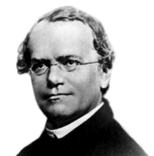

Law of *
Segregation:

*

*

Law of *
Independent
Assortment:
*

*

Alleles:

Dominant:

Recessive:

Incomplete
Dominance:
Codominance:

Sex-linked:

Selective Breeding:

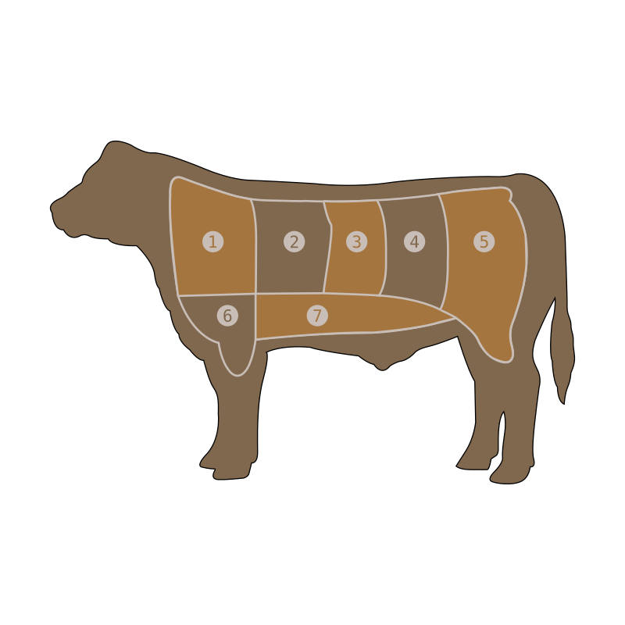
Examples: * * * * * * *
