Freshman Biology Genetics – Std 4/Obj 1 Study Guide

Meiosis I
_______________
_______________
_______________
_______________
_______________

Interphase I:

Prophase I:

Metaphase I:

Anaphase I:

Telophase I
& Cytokinesis:

______________
______________
______________
______________

Meiosis II

Prophase II:

Metaphase II:

Anaphase II:

Telophase II:

Diploid:

Haploid:

How many chromosomes does each of our (human) cells have?

Chromosome:

Gene:

Homologous:

Gamete:

Fertilization:

Mitosis vs. Meiosis:

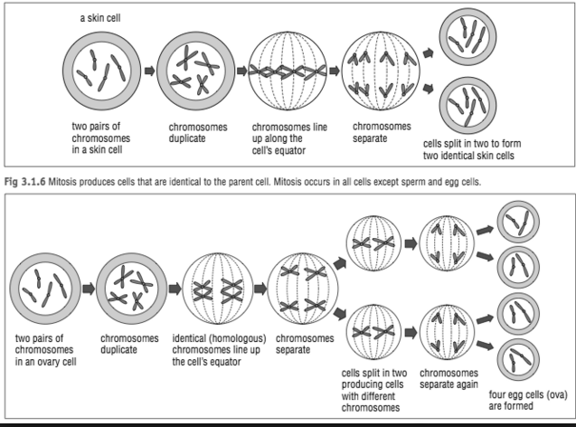
Genetic Variation:
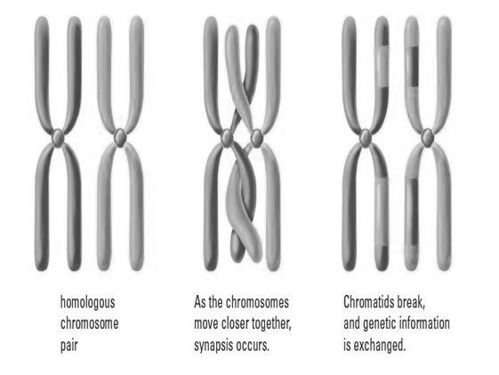
Crossing Over:
Sexual Reproduction:

Asexual Reproduction:

Mutation:

Mutagen:

Bioethics:

