9th Grade Biology Standard 2/Objective 2 – Study Guide

Auto:

Hetero:

Trophic:

Autotrophic:

Heterotrophic:

3 Types of:
Energy
Reactions:

Photosynthesis:

Respiration:

Fermentation:

Interactives: sites.ext.vt.edu/virtualforest/modules/photo.html
sepuplhs.org/high/sgi/teachers/photosynthesis2_sim.html
http://glencoe.mheducation.com/sites/dl/free/0078802849/383932/BL_25.html
https://www.exploringnature.org/db/view/1045

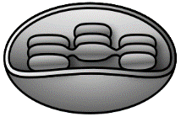
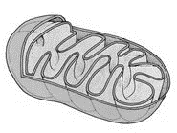
Mitochondria
Chloroplast
6CO₂ + 6H₂O + C₆H₁₂O₆ + 6O₂
6CO₂ + 6H₂O + C₆H₁₂O₆ + 6O₂

How much carbon dioxide/oxygen do small materials produce? – Photosynthesis/Respiration Demonstrations

What are the differences between aerobic and anaerobic respiration?

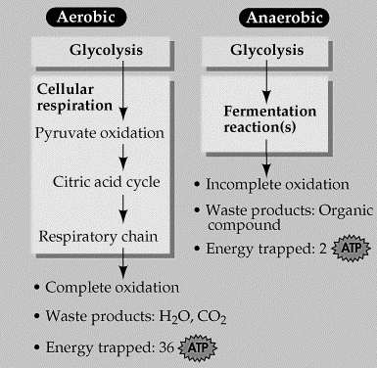
Notes:

What are the advantages of aerobic respiration?

Fermentation – Sourdough Activity

