Name ________________________________________ Period ____________ Date ___________________

Genetics: X Linked Genes

In fruit flies, eye color is a sex linked trait. Red is dominant to white.

1. What are the sexes and eye colors of flies with the following genotypes:

X ^{R} X ^{r} _________________ X ^{R} Y _________________
X ^{R} X ^{R} _________________ X ^{r} Y _________________

2. What are the genotypes of these flies:

white eyed, male ____________ red eyed female (heterozygous) ________
white eyed, female ___________ red eyed, male ___________

3. Show the cross of a white eyed female X ^{r} X ^{r} with a red-eyed male X ^{R} Y .
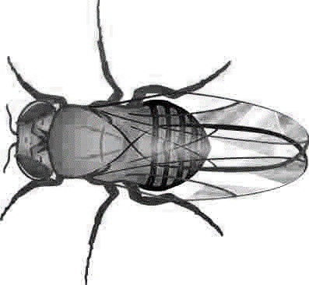

4. Show a cross between a pure red eyed female and a white eyed male.
What are the genotypes of the parents:
___________& _______________

How many are:
white eyed, male___
white eyed, female ___
red eyed, male ____
red eyed, female ____

5. Show the cross of a red eyed female (heterozygous) and a red eyed male. What are the genotypes of the parents?
___________ & ________________

How many are:
white eyed, male___, white eyed, female ___
red eyed, male ____, red eyed, female ____

Math: What if in the above cross, 100 males were produced and 200 females. (Think about the percentage of the total #.) How many total red-eyed flies would there be? 6.

7. In humans, hemophilia is a sex-linked trait. Females can be normal, carriers, or have the disease. Males will either have the disease or not, but they won’t ever be carriers.

= female, normal  = female, carrier  = female, hemophiliac | = male, normal  = male, hemophiliac

Show the cross of a man who has hemophilia with a woman who is a carrier.

8. What is the probability that their children will have the disease? __________

9. A woman who is a carrier marries a normal man. Show the cross. What is the probability that their children will have hemophilia? What sex will a child in the family with hemophilia be?

10. A woman who has hemophilia marries a normal man. How many of their children will have hemophilia, and what is their sex?

