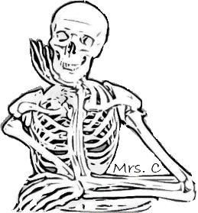
Classroom Policies – Freshman Biology – 2019/2020

Website
- mrscbiology.com
  - Calendar, assignments, due dates, testing dates, scheduled events, class photos, videos, lab information, study guides, supplemental study materials, etc.
  - Students and parents should check the website regularly.
  - Students who ask, “What did we do in class yesterday?” will always be replied to with, “Check the website.”

Grading
- Everything Counts!
- Formal assessments – 80%
- Initial Work (lab books, assignments, presentations, investigations, scientific procedure, practice) – 20%
- Final Work – students will revise and perfect their lab books, assignments, presentations, investigations and practice. These scores will eventually become a formal portfolio assessment, which will then be graded at the 80% level.
- Students can track their learning progress by using the Biology Learning Goals (Proficiency Scales). Each student has a copy of these goals, or they can be accessed at mrscbiology.com.

Assignments
- Assignments and lab books are not just busy work. By working through and perfecting the content of these learning materials, students will demonstrate their understanding and application of the scientific process as it pertains to biology.
- Regarding grades, final submissions (assignments, labs, lab books, etc.) will have the same weight as formal assessments.
- If students do not complete and refine each assignment or other required submission, it will show in their formal test grades.
- If students are absent, it is their responsibility to obtain and complete any missed assignments and/or notes – check the website.

Tests
- There are eight formal assessments (tests) scheduled for Biology (two per standard) – multiple choice, 20-30 questions.
- Test checklists will be available to prepare for each formal assessment.
- Scientifically-proven study skills will be taught to help students prepare for formal assessments.
- For any missed formal assessment, students will take an alternative assessment that covers the same material as the original, but is not identical.
- For any missed formal assessment, students are required to take the alternative assessment the day they return to class.

Test Retakes
- Students may retake a formal assessment only once.
- Test retakes cover the same material as the original formal assessment, but are not identical.
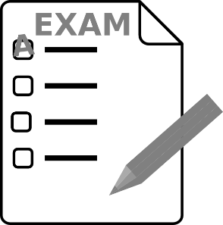
- Students must complete “Test Paragraphs” for the original test and revise/resubmit all assignments, labs, lab books, etc., before retaking any formal assessment.
- Due dates for test retakes:
  - 1st Quarter – Tuesday, October 15
  - 2nd Quarter – Tuesday, January 14
  - 3rd Quarter – Monday, March 23
  - 4th Quarter – Monday, June 1
- No test retakes may be taken after these dates.

Test Paragraphs
- The rubric for test paragraphs will be handed out and explained after the first formal assessment.
- No test retakes may be taken without completion of test paragraphs.

Citizenship Grades
- Good citizenship grades are earned by treating others with courtesy, keeping one’s hands to oneself, participating appropriately in the day’s activities, treating the classroom facilities properly, having good attendance/minimum tardies, following the teacher’s directions, being honest in your work, and refraining from disruption of any kind.
  - H – All assignments, labs, lab books, etc., completed and submitted; no more than one (1) unexcused tardy; no more than five (5) absences; no electronics violations.
  - S – No more than one (1) missing assignment, labs, lab books, etc.; no more than two (2) unexcused tardies; no more than nine (9) absences; no more than one (1) electronics violation.
  - N – Three (3) or more missing assignments, labs, lab books, etc.; no more than three (3) unexcused tardies; ten (10) or more absences; no more than two (2) electronics violations.
  - U – Four (4) or more missing assignments, labs, lab books, etc.; four (4) or more unexcused tardies; ten (10) or more absences; three (3) or more electronics violations.
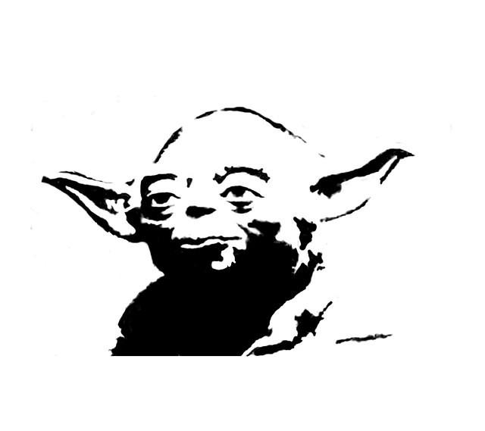
- Academic dishonesty, bullying, defacing classroom property, major or consistent classroom disruption, or sluffing class will result in an automatic “U”.
- Student Interaction – The classroom is not the place for public displays of affection (PDAs), i.e. hugging, holding hands, kissing, sitting in someone’s lap, sharing chairs, playing with another’s hair, cuddling. Engaging in PDAs may decrease the citizenship grade.

Extra Credit
Do or do not.
- There is no such thing.

iFlight
- Biology is taught at a high level, according to established state core standards. If students do not attend class every day, pay attention, take good notes, complete all labs and assignments, and review regularly, they will have a difficult time.
- Students who need help with assignments, labs, instruction, test preparation, etc., may sign up for iFlight by filling out an iFlight slip and placing it in the bucket (on the podium).
- Parents will be notified, on a regular basis, if their student fails to submit “proficient” work – see Biology Learning Goals (Proficiency Scales) handout.
- iFlight is not for socialization or chatting. Students who misuse iFlight time will not be further admitted.

Beginning of Class
- Students are expected to be in their seats, with all electronics stored out of sight, already beginning the day’s activities when the bell rings. This is accepted scientific procedure and is part of the student’s grade.
- Instructions for the beginning of class will be on the board every day – read it and do it.
- Parents will be notified of every tardy.
- Tardies will be dealt with according to the SRMS Student Handbook, which may include an administrative referral and parent conference.
- See the Citizenship Grades heading for information on how tardies affect citizenship grades.

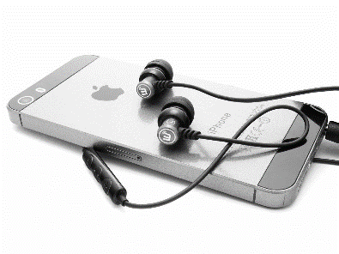
Electronics
- BEFORE!!! entering the classroom
  - Phones, headphones, mp3 players, tablet computers, earbuds, etc. – out of sight.
  - Yes! – Pocket, notebook, backpack or other such out-of-sight place.
  - No! – On the floor, in a lap, on the desk, or hanging from your neck/collar/sleeves/ears.
  - Finish all phone calls and texting before entering the classroom.
    - All Offenses:
      - Phone is deposited in locker
      - Student remains behind after class
      - Parent will be notified
      - Citizenship grade will be affected (Note: some lab participation is determined by citizenship grades)
      - Repeat offenders will be referred to administration
Dress Code
- Students are required to follow the district’s dress code and will be referred to the main office if they are not dressed appropriately. See the SRMS Student Handbook for dress code particulars.

Seating Chart
- There is a seating chart for all classes.
- Sometimes we will have other seating arrangements; however, the seating chart is the default place unless otherwise directed.
Bullying
- Bullying will not be tolerated.
- Examples of bullying that students may not have considered: hiding someone’s possessions, name calling, tripping, throwing items at someone . . . in short, anything that deliberately causes discomfort to another person is bullying.
- “I’m just having fun” or “I’m just kidding” excuses do not cut it in Biology class.
- The school district’s bullying policy will be strictly followed.
- See the Citizenship Grades heading for information on how bullying may affect citizenship grades.
Classroom Maintenance
- The classroom will return to the same condition at the end of the period as it was when the period started.
- Any debris on or around desks or work areas must be cleaned up before the bell rings.
- Students will not be released until the classroom condition has been approved.
- A two-minute alarm will sound at the end of each period, so students have time to return/plug in computers, pack their belongings, and “police” the classroom.

Food
- Food is not allowed in the biology classroom; however, students may have water (not Gatorade, juice, soda, etc.).
- Water must be in plastic or metal containers with a screw-on lid – no glass or open containers.
Furniture
- Feet belong on the floor – not the desk or the chair.
- Drawing or otherwise marking on classroom furniture is considered “defacing classroom property.” See the Citizenship Grades heading for information on how this may affect citizenship grades.
- Each class period will occasionally be required to clean the lab tables and countertops. Cleaning materials and gloves will be provided so students and teacher can work together to keep the biology lab tidy.

Off-Limits Areas
- Students are not to touch/mess with items on or around the teacher’s desk, the front lab counter and sink, the audiovisual equipment, or any of the drawers or cupboards.
- Students will not go behind the teacher’s desk or lab table, unless invited to do so.
- Except for biology labs or at the teacher’s direction, use of the biology lab faucets and sinks is prohibited.
- Students wishing to wash their hands or get a drink of water may use the facilities located in the pod outside the classroom.
- Sitting at tables or unassigned areas are by permission only.
- Rolling chairs are to remain in their designated places.
- Whiteboards are for the teacher’s use, unless you are specifically directed to use them.

Materials Needed
- There are not enough funds for the school to provide students with all materials. Students should come to class – every day – with the following items:
  - Pencil, eraser, lined paper, lab book, binder, and assignments/packets/labs/handouts.
  - Being prepared with these items, every day, is accepted scientific procedure and is part of students’ grades.
- For students who occasionally need materials, the student supply cart has lined paper, staples, pencil lead, pencils, erasers, paperclips, staplers, tape, tissues and a three-hole punch.
- Please return pencils and erasers after the class period and only take/use other items for immediate classroom use.

Recycling
- Blue recycling bins are provided in the classroom. All paper, aluminum, and plastic are to be disposed of in this bin.
- Recyclable materials are not to be thrown in the trash.

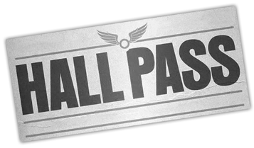
Hall Pass
- Students may use the hall pass under the following conditions:
  - One at a time – only twice per week – 5-minute maximum
  - Tear off name and place in bucket on podium.
  - Enter and return through the front hallway door.
  - Wear the hall pass. Do not put the pass down anywhere in the school bathrooms – eww!

Photos
- Students are not allowed to take photos of each other in the classroom.
- Photos may be taken of the whiteboard or other materials in the room, for educational use.
- Photos may be taken by the teacher for use in constructing seating charts and to contribute to the Freshman Assembly. These photos will be used for school purposes only.

Special Activities
- Some labs and activities will be open only to those students who are not behind in their classwork and/or have a current citizenship grade of “H” or “S”.
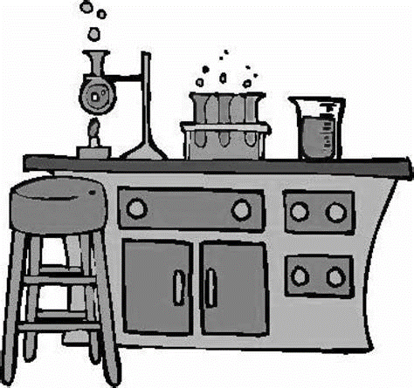
- These criteria must be met to participate in the dissections as part of Standard 2. Students not meeting these criteria will be given an alternative assignment.

Mrs. Clelland
mrscbiology.com
erin.clelland@jordandistrict.org

Notes:

