Name _________________________________ Period ________________ _________ / 30

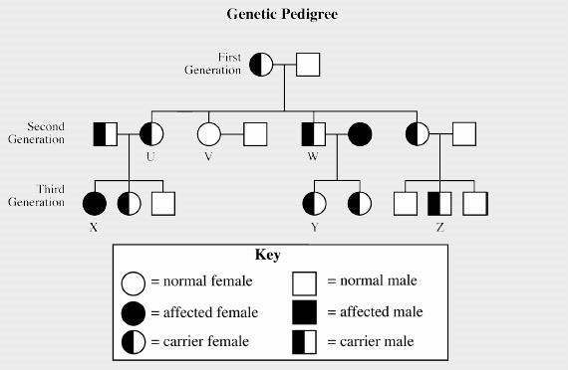
Pedigree Review Worksheet
Sickle cell anemia (sickle cell disease) is a disorder of the blood caused by an inherited abnormal hemoglobin (the oxygen-carrying protein within the red blood cells). The abnormal hemoglobin causes distorted (sickled) red blood cells. The sickled red blood cells are fragile and prone to rupture.
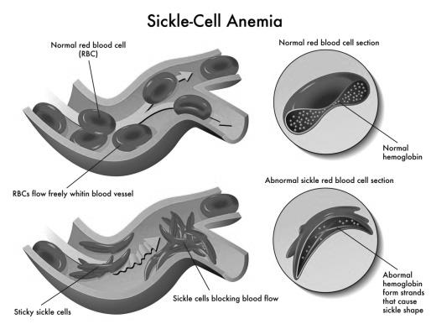
- How many generations are shown on this pedigree? 3
- Which parent in the first generation has sickle cell anemia? Neither
- How many children were born in the 2nd generation? 4
- How many individuals in the 2nd generation are carriers for sickle cell anemia? 4
- How many offspring in the 3rd generation have sickle cell anemia? 1 How many are carriers? 4
- Is sickle cell anemia a sex-linked trait? No How do you know? Sickle cell anemia is autosomal recessive. Both males and females can be carriers.
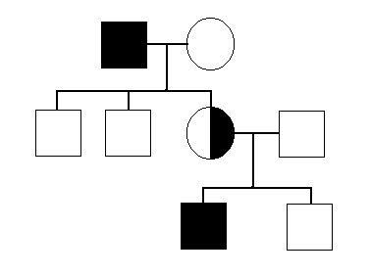
- Is the gene for sickle cell anemia likely to be dominant or recessive? Recessive Explain your answer. The F₁ and F₂ generations can be carriers, but none exhibit the disease.
- What do circles represent? Females
- What do squares represent? Males
- What do the colored squares represent? Affected or exhibiting the trait/disease
- What does a horizontal line between a circle and square represent? Married
- What does a vertical line represent? Offspring
- What does the half shaded circle represent? Carrier
- How are several children from a marriage represented? Along a horizontal line
- Is this a dominant, recessive, or sex-linked trait? Dominant

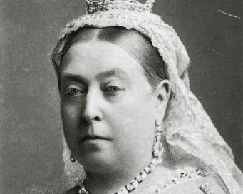
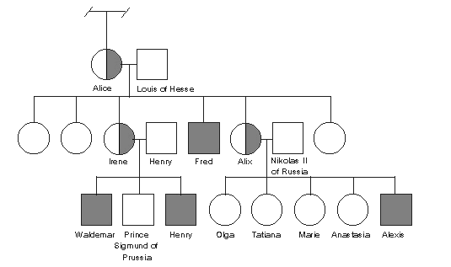
Below is part of the pedigree of Queen Victoria of England. This pedigree represents the occurrence of hemophilia in her family. Only some of her family members have been included.
Queen Victoria
Haemophilia, also spelled hemophilia, is a mostly inherited genetic disorder that impairs the body's ability to make blood clots, a process needed to stop bleeding. This results in people bleeding longer after an injury, easy bruising, and an increased risk of bleeding inside joints or the brain.
- How many male grandchildren were hemophiliacs? 1
- How many of the great-grandchildren were hemophiliacs? 3 How many were girls? 0 How many were boys? 3
- Is it more likely for males or females to get hemophilia? Males Explain your answer. Females were either carriers or unaffected entirely. According to the pedigree chart, no females had the disease.
- Why were all the carriers in Queen Victoria’s family female? Hemophilia is caused by a recessive allele found only on the x chromosome. A female has two x chromosomes. A male only has 1 x chromosome. Therefore, a male needs only one recessive allele to have hemophilia, while a female needs two recessive alleles. As a result, hemophilia is much more common in males.
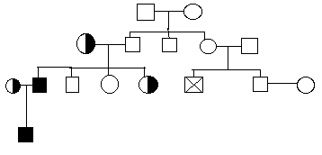
- How are pedigrees helpful in determining family traits? A pedigree chart is a diagram that shows the occurrence and appearance (phenotypes) of a particular gene from one generation to the next, which can help predict future outcomes.
X

- Hemophilia is a sex-linked disease. If “X” represented in this pedigree is a male child, what is the probability that he will be affected with the disease?

  - 0%
  - 50%
  - 25%
  - 100%

- How many affected individuals are shown in this pedigree?

  - 4
  - 3
  - 2
  - 1

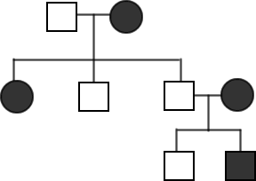
- Albinism results in the body being unable to make a protein needed for production of melanin, which gives up our skin, hair, and eye pigment. According to this pedigree, what kind of trait is albinism?

  - operon
  - recessive
  - dominant
  - sex-linked

- Based on this pedigree, how would you describe the mother labeled X?
X
  - affected
  - living
  - carrier
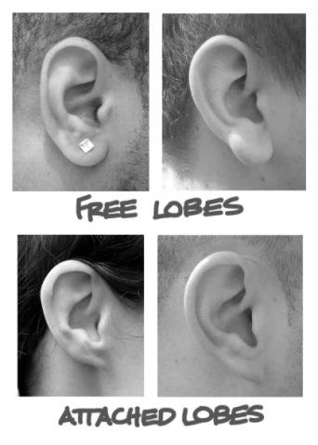
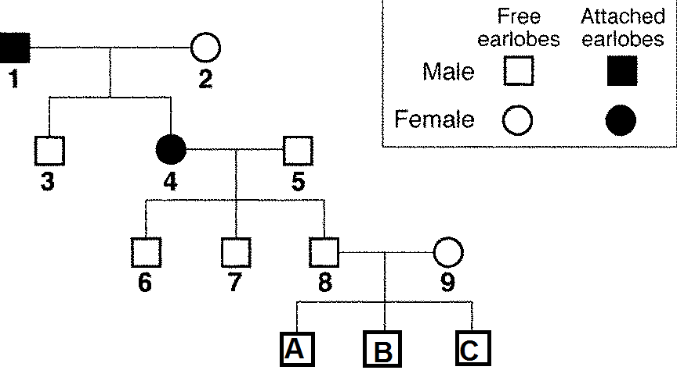
  - normal

- In this pedigree, is individual 2 homozygous or heterozygous? Homozygous recessive
- How many children of individuals 4 and 5 have attached earlobes? 3
- Can you be certain of the genotype of individual 5? Yes Explain Attached earlobes are recessive. If he were heterozygous, he would exhibit the trait.
- Predict the genotype and phenotype of individual A. Homozygous recessive; attached earlobes
- Are any of the descendants of individuals 1 and 2 homozygous for free earlobes? Yes - #3
- Do you have attached or free earlobes? ______________ What is your genotype? ______________

