Organelle | Image | Function
Cytoplasm | 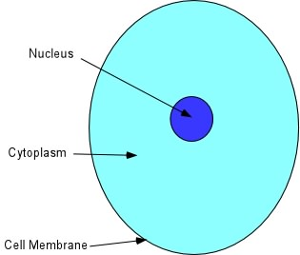 | - Gel-like substance holding the other organelles in place  - Made mostly of water  - Clear in color  - Contains enzymes, salts, organelles, and various organic molecules
Cell Membrane | 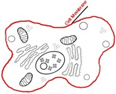 | - Semi-permeable membrane  - Surrounding cytoplasm of cell  - Controls what comes in and out of cell  - “Border patrol” of the cell
Cell Wall | 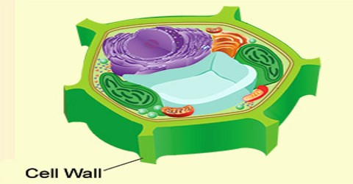 | - Found only in plant cells  - Rigid  - Provides structure
Chloroplast | 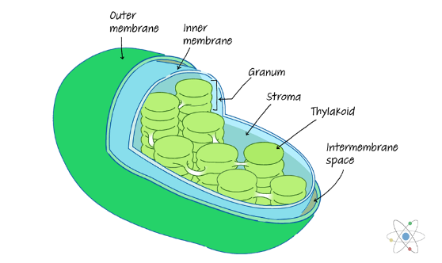 | - Found only in plant cells  - Conducts photosynthesis  - Filled with chlorophyll
Mitochondria | 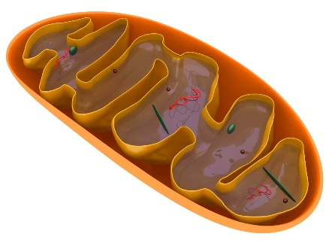 | - Cellular respiration  - ATP synthesis  - Breaks down glucose  - “Powerhouse” of cell
Ribosome | 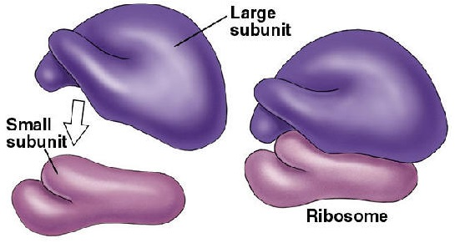 | - Protein synthesis  - Links amino acids together in peptide chains (translation)  - Made of RNA  - Found in cytoplasm and on RER
Vacuole | 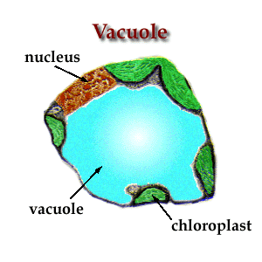 | - Contains waste products  - Contains water in plant cells  - Maintains turgidity in plant cells  - Isolates harmful materials
Nucleus | 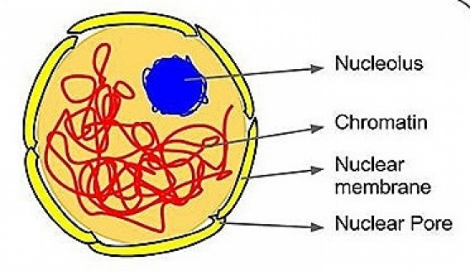 | - Controls functions of cell  - Regulates gene expression  - “Brain” of the cell  - Where DNA is found
Rough Endoplasmic Reticulum (RER) | 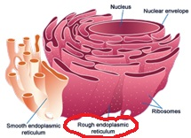 | - Export of proteins  - Found near the nucleus  - Ribosomes on outside  - Folds proteins into their 3-D shape  - “Highway” of the cell
Smooth Endoplasmic Reticulum (SER) | 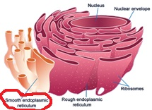 | - Phospholipid and cholesterol synthesis  - Smooth and slippery  - No ribosomes
Golgi Apparatus (Golgi Body) | 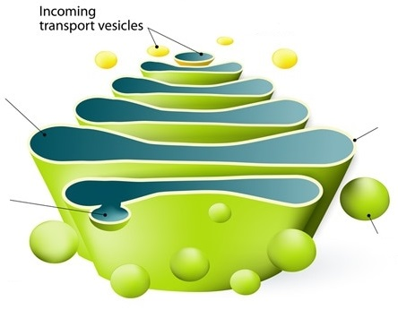 | - Collects and exports of proteins received from RER  - Packages proteins into vesicles  - Sent out of cell (exocytosis) or used in cell  - “Post office” of the cell  - Looks like stacked pancakes
Lysosome | 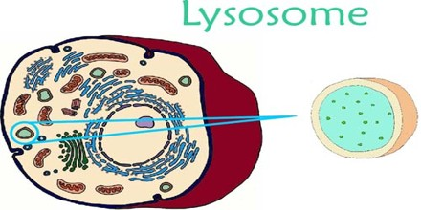 | - Engulfs and breaks down biomolecules  - Contains digestive enzymes  - Removes bacteria and food particles from cell  - “Garbage disposal” of the cell
Centrosome | 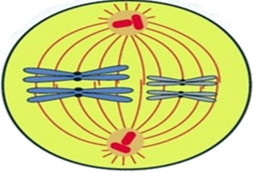 | - Directs microtubule movement  - Pulls chromosomes to opposite sides of the cell during mitosis

