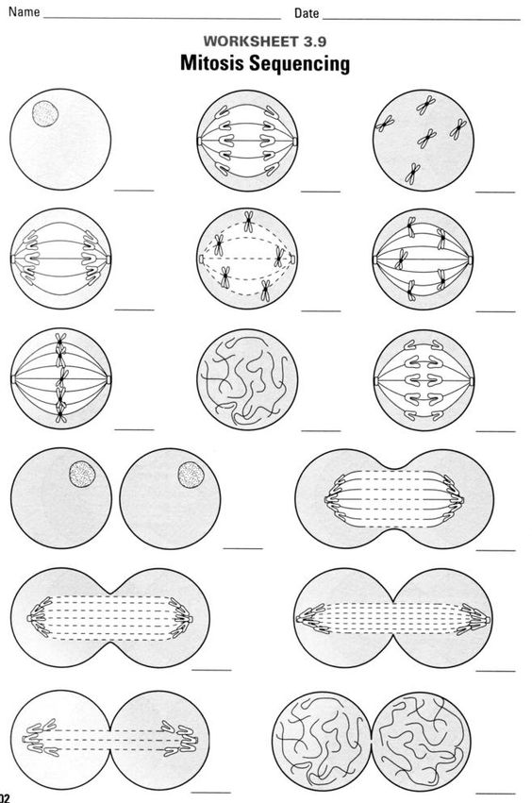

**INTERPHASE**

**ANAPHASE**

**PROPHASE**

**ANAPHASE**

**ANAPHASE**

**TELOPHASE**

**TELOPHASE**

**TELOPHASE**

**TELOPHASE**

**METAPHASE**

**METAPHASE**

**METAPHASE**

**PROPHASE**

**INTERPHASE**

**CYTOKINESIS**

1

2

3

4

5

6

7

8

9

10

11

12

13

14

15