Heart Rate Activity

- As a group, choose five (5) activities at different levels, designed to show various heart rates.
  - The only variable for each test should be the activity itself. Try to keep everything else constant: time, distance, location, time in between each activity, number of repetitions, etc.
  - Be detailed in how the activity will be performed.
  - Duration of each activity should not be too long.
- Copy this table into your lab book – use your activities for the column headings.

 | Heart Rates – beats/minute (bpm)
 | Pre-Activity BPM | Activity #1 BPM | Activity #2 BPM | Activity #3 BPM | Activity #4 BPM | Activity #5 BPM
Participants
Average BPM
(bpm total ÷ # of participants)

- All group members should participate in the activity (if possible).
- After each activity, record each participant’s heart rate in the appropriate column.
  - Use the carotid pulse
  - Count pulse beats for 6 seconds
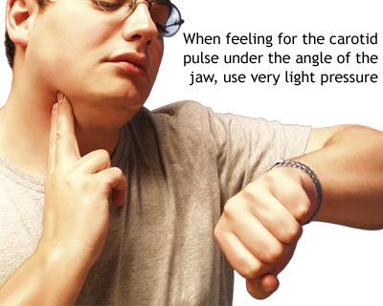
  - Add a zero to your count for the bpm
- Allow a cool-down period of 2-3 minutes between each activity.
- When finished:
  - Calculate the average heart rate for each activity – record it in the appropriate column.
  - Use your data to explain what you learned about heart rates – how and why they adjust in order to keep your body in homeostasis.
  - What other organ systems did you notice that also worked to keep your body in homeostasis, as you engaged in each activity? How did these other organ systems do this?
  - How is this Heart Rate Activity an example of feedback mechanisms?

