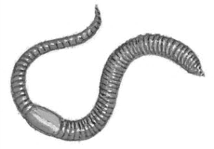
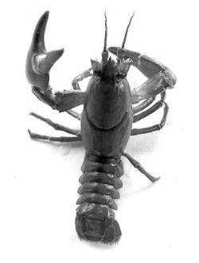
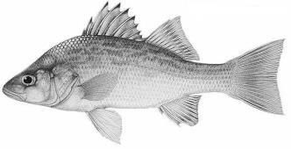
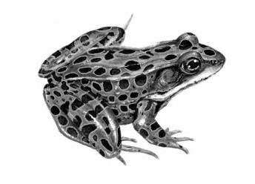
Name __________________________________ Period _______ Date _____________

Dissection Lab Safety and Clean-up Procedures
Teacher signatures confirming I have viewed all required videos and materials for the following:

________________________ Earthworm ________________________ Perch (Fish)

________________________ Crayfish ________________________ Frog

- Certification: Certify each day that you have viewed the assigned videos and materials and sign your signature next to the appropriate dissection specimen.
- Groups: Students will work in groups of three. Each group will decide how to divide the dissection responsibilities. There will be one specimen for each group; however, each student will turn in their own lab paper.
- Gloves: Only one pair of gloves is allotted for each student per day.
- Goggles and Lab Coats: Students must wear goggles and a lab coat while performing dissections.
- Equipment: Each group will need a dissection tray and cover, a dissection kit (scalpel, scalpel cover, forceps, scissors, ruler, pipette, and two probes), one specimen, iPad, and a few T-pins.
- Contamination: Notify your teacher immediately if you are splashed with dissection fluids.
- Scalpels: Hold the scalpel with your index finger guiding the blade. Always cut away from your body. Never cut toward your fingers or other body parts. When not in use, the scalpel should be placed on the table, away from the edge. ***Scalpels are for cutting only – do not probe, point, wave, or use the scalpel for anything other than cutting!***
- Broken Scalpels: If you break a scalpel, or any other sharp lab instrument, the blade should be placed in the “sharps container” at the front of the room. ***Do not throw broken scalpel blades in the trash!***
- Clean-up: You will have five minutes at the end of class to clean up each day. No student will be allowed to leave the lab until all clean-up has been completed by all students.
- Specimens: If you are finished with your specimen, place it in the disposal bucket. If you are not finished with your specimen, put it in a plastic baggie, label the baggie with a Sharpie, and place the specimen on the top shelf (either side of the room). ***Do not throw specimens in the trash!***
- Clean Instruments: Before placing scalpels or other instruments back into the dissection kit, clean them with water and paper towels. Make sure all instruments are completely dry.
- Dissection Kits: All items must be placed back in the dissection kits (scalpel, scalpel cover, scissors, forceps, pipette, ruler and both probes). Wipe off T-pins and replace in container.
- Trays: Clean dissection trays by running them under water and then pat-drying them with a paper towel.
- Return Materials: All equipment and materials must be returned to their proper place each day. No student will be allowed to leave the lab until everything is in its place.
- iPads/Chromebooks: Return iPad/Chromebook to proper slot in cart. Make sure it is plugged in.
- Tables: At the end of each lab, all tables must be cleaned with antibacterial spray and a cloth.
- Hands: Students must wash their hands before leaving the lab each day.
______________________________________ I have read, understand, and agree to follow the above lab safety and clean-up procedures.

