**Data for Biology Test 1-3 (Std 1/Obj 3) *Interactions with Organisms and the Environment***

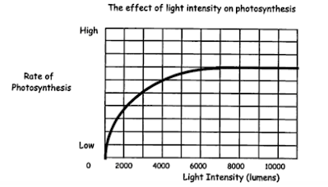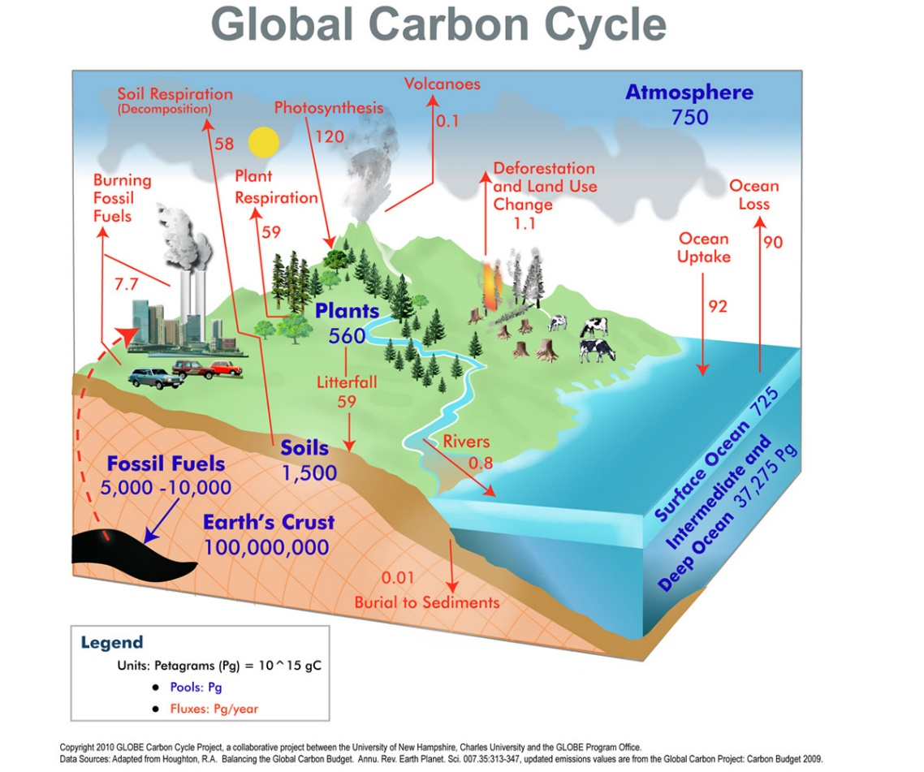

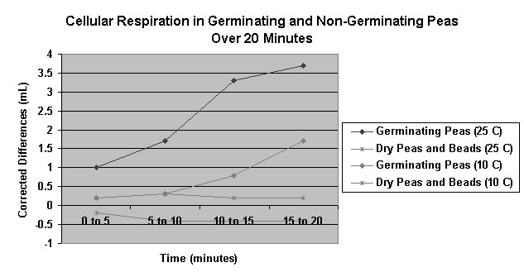

*Germination – the beginning of vegetation or growth from a seed or spore*