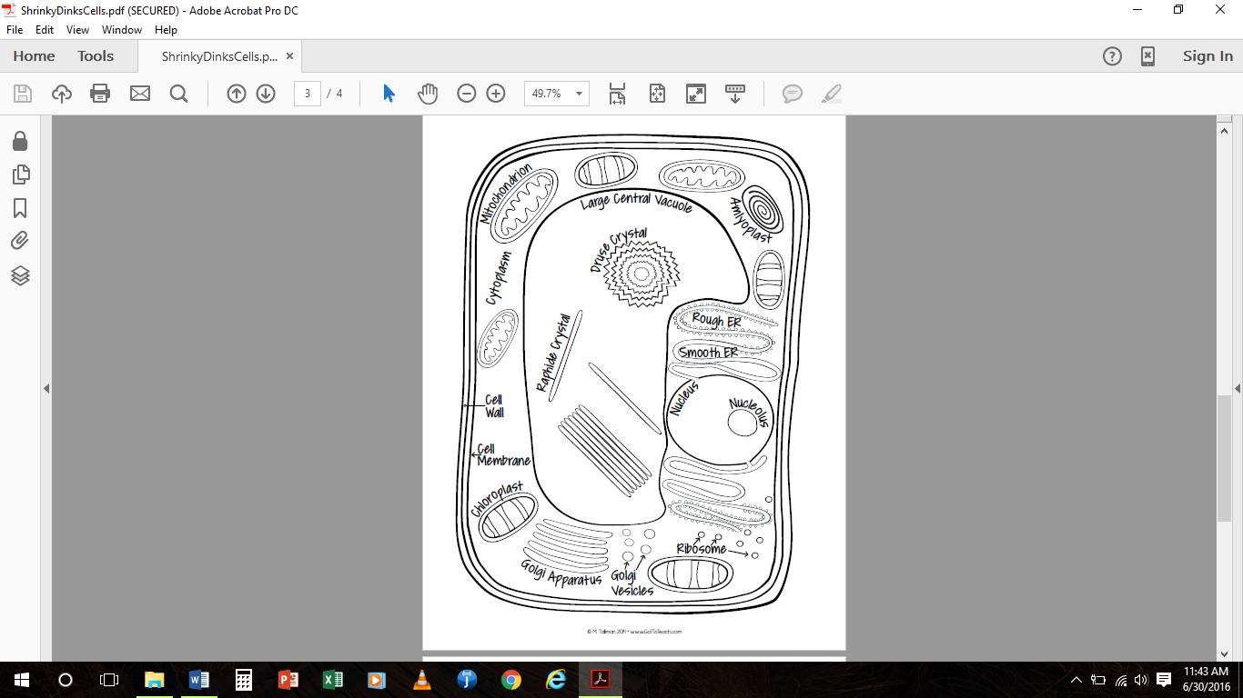

Name ________________________ Period ____________

PLANT

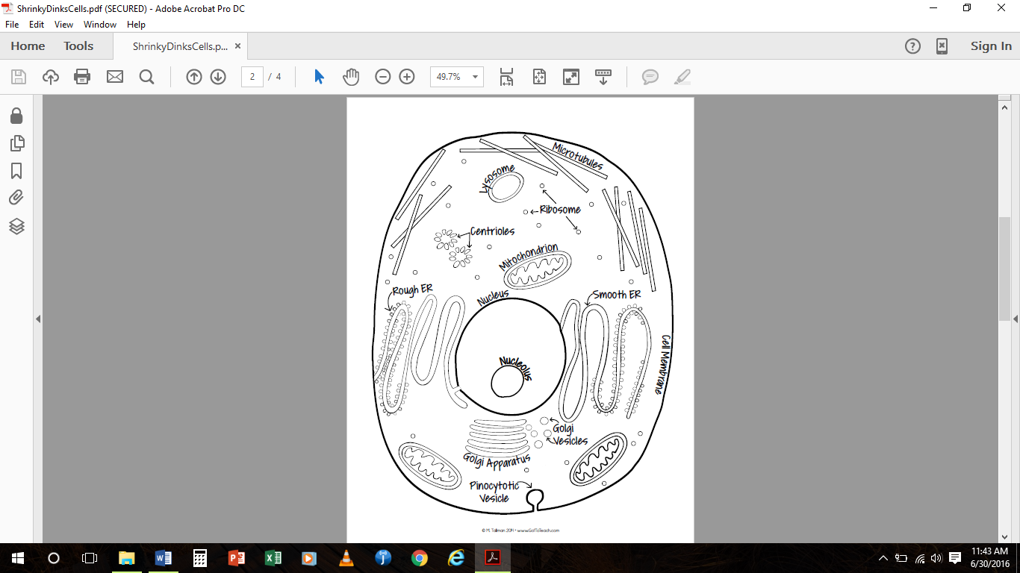

ANIMAL

Name ________________________ Period ____________